

Back – End Developer
Smart Job Portal System

Academic Year | Module | Assessment Number | Assessment Type
2026 | 5CS024 – Collaborative Development | Portfolio 1 | Individual Report

Student ID: 2462250
Student Name:Praju Maharjan
Group: L5CG9
Module Leader: Yogesh Bikram Shah
Tutor: Ms. Nerisha Shrestha
Submitted On: 20 March 2026
Table of Contents
Self-appraisal Form………………………………………………………………………………………………………1
1. Personal Objectives – Performance Measurement……………………………………………………..1
1.1. Appendix A (Choosing Relevant Technologies……………………………………………………...3
1.2. Appendix B (Implementing Functional Requirements…………………………………………….…4
1.3. Appendix C (Use of Version Control) …………………………………………………………….…8
1.4. Appendix D (Team Collaboration and Communication) ……………………………………….……9
1.5. Appendix E (Sprint Review) ………………………………………………………………………..12
2. Issue Tracking…………………………………………………………………………………………13
3. Work to Deadline………………………………………………………………………………………14
4. Sprint Retrospective……………………………………………………………………………………14
4.1. What Went Well…………………………………………………………………………………..…14
4.2. What Could Be Improved……………………………………………………………………………15
5.Conclusion…………………………………………………...……………………………………….…15
References…………………………………………………………………………………………………16

Self-appraisal form

Student number | 2462250 | Name | Praju Maharjan
Project | Smart Job Portal System(KaamKhoji) | Date | 2026/04/20
Role | Developer | Team | L5CG9
Sprint (1 or 2) | 1

1.Personal objectives – Performance Measurement

Objectives | Evidence provided  (E.g. appendix A, file name etc.) | Evaluation  Student / tutor
Choosing Relevant Technologies | After numerous discussions, HTML, CSS, Vanilla JavaScript, PHP and MySQL were selected as the  final tech stack based on the project’s requirements, the simplicity and the team’s familiarity with the languages. Further evidence provided in Appendix A. | 9/10
Tutor feedback:

Implementing Functional Requirements | Three separate dashboards: Employee, job-seeker and admin were created ; each with their own functionalities, including job search and password changing. Further evidence provided in Appendix B. | 20/20
Tutor feedback:

Use of Version Control | Git and GitHub were extensively used to track changes to the code. To ensure that changes to the code did not break the working application, each additional feature was commited to a separate branch.  Further evidence provided in Appendix C. | 8/10
Tutor feedback:

Team Collaboration and Communication | The primary communication platforms for the team were Discord and WhatsApp. The Project Manager used Gmail to schedule regular online meetings on Discord while informal communication was carried out using WhatsApp messages.  Further evidence provided in Appendix D. | 8/10
Tutor feedback:
 |  | 45/50 | /50

1.1. Appendix A (Choosing Relevant Technologies)
The following programming technologies were selected for the project :
- HTML(HyperText Markup Language)
HTML was chosen as the markup language to build the basic structure of the web application. It helps in arranging different parts of the webpage like headings, navigation bars, forms, and footers. HTML5 was chosen primarily as it is supported by all modern browsers, which makes it reliable to use. In this project, HTML was mainly used to organise the content and give proper structure to the pages.
- CSS( Cascading Style Sheets)
CSS was used to design how the website looks. It controls things like colors, layout, spacing, and overall appearance. By using CSS, the design is kept separate from the HTML, which makes the code easier to manage. In the project, features like Flexbox, Grid, and media queries were used to make the website responsive so that it works well on both desktop and mobile devices.
- JavaScript
JavaScript was used to add interactivity to the website. It allows the webpage to respond to user actions without reloading the page. In this project, JavaScript was used for handling button clicks, validating forms, updating content on the page, and fetching data from the backend.
- PHP
PHP was used for the backend tasks of the application. It handles the behind the scenes logic, such as processing user input, communicating with the database, and sending data back to the frontend. PHP is easy to use and works well with MySQL, which is the reason it was chosen for this project.
- MySQL
MySQL was used to store the data of the application. It is a relational database system, which means data is stored in tables. In this project, several tables were created to store different types of data, and primary and foreign keys were assigned to them to prevent data duplication and connect the different tables to each other.
- GitHub
GitHub was the undisputed choice to manage the project code and work as a team. All members uploaded their work to a shared repository with separate branches for each feature so that multiple people could work at the same time without causing problems. Commits helped keep track of changes and each commit was communicated to the group via unofficial channels so that every team member was always on the same page.
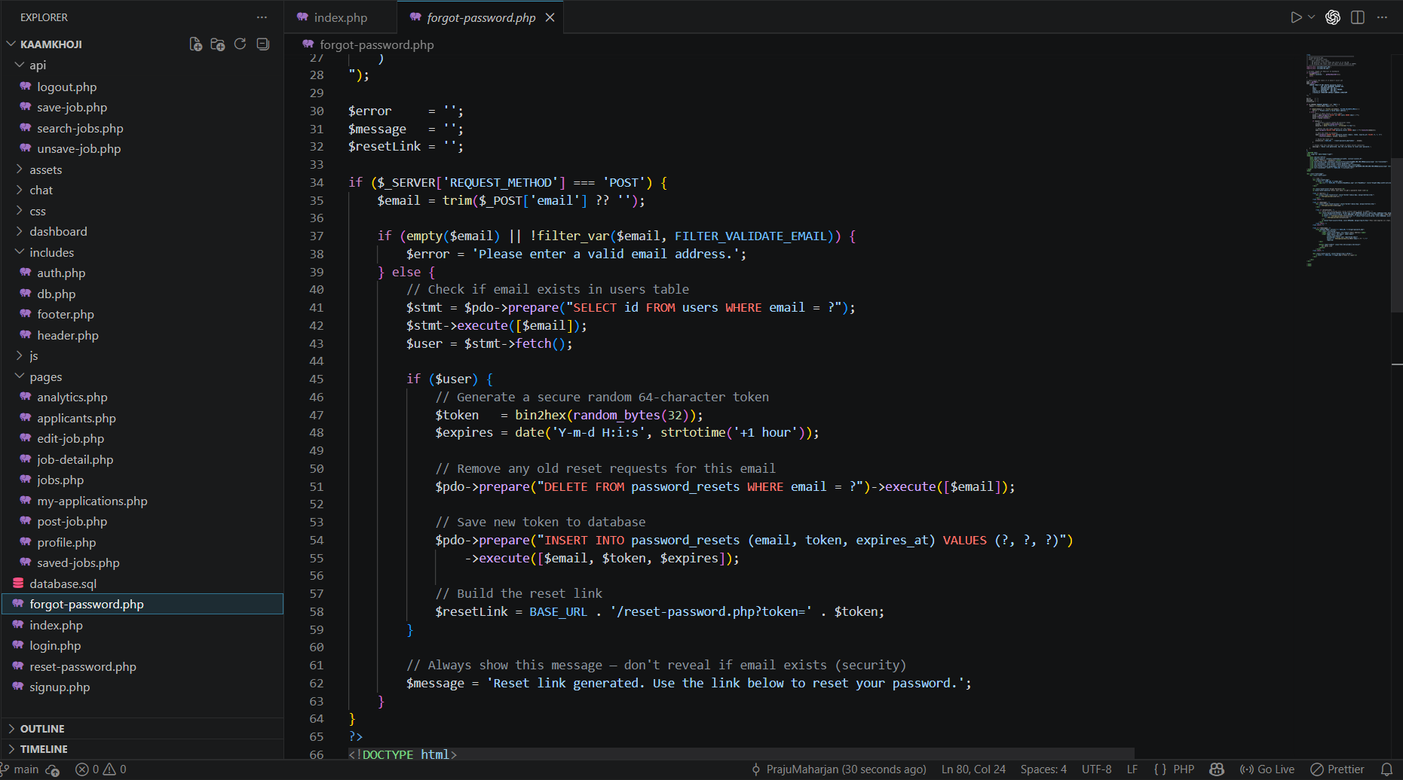

Fig :- Sample File of the application

1.2. Appendix B (Implementing Functional Requirements)
Sprint 1 focused on building the foundational layer of the application. The following development activities were completed during the sprint:
- Project structure : The directory structure for the application was created and agreed upon, separating frontend assets (HTML, CSS, JavaScript) from backend scripts (PHP) .
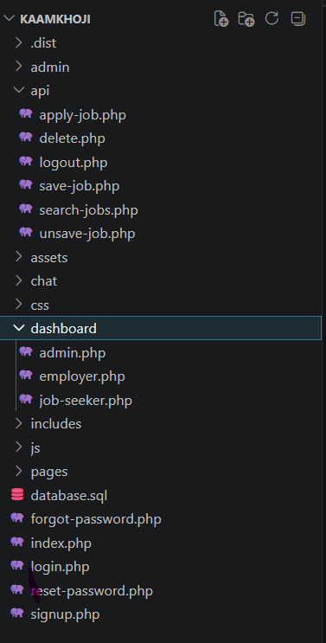
Fig :- Directory Structure of KaamKhoji

- Database design and connection: The MySQL database schema was designed, including the creation of core tables and the definition of relationships between entities. A separate PHP database connection file was created to manage database connectivity.
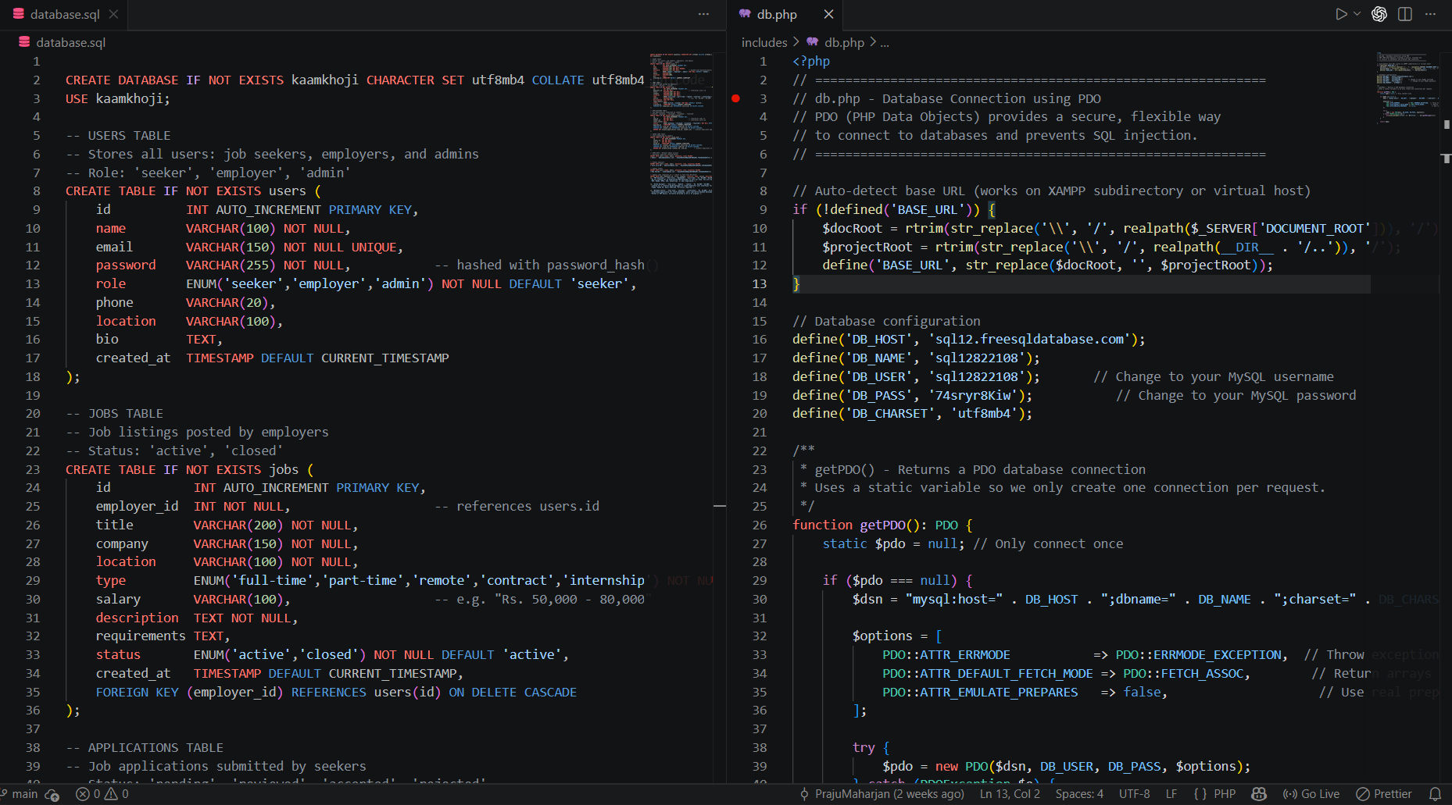
Fig:- Database Schema

- Initial frontend pages: Core frontend pages were developed using HTML and CSS, establishing the visual structure of the application including the home page, login page, and registration page.
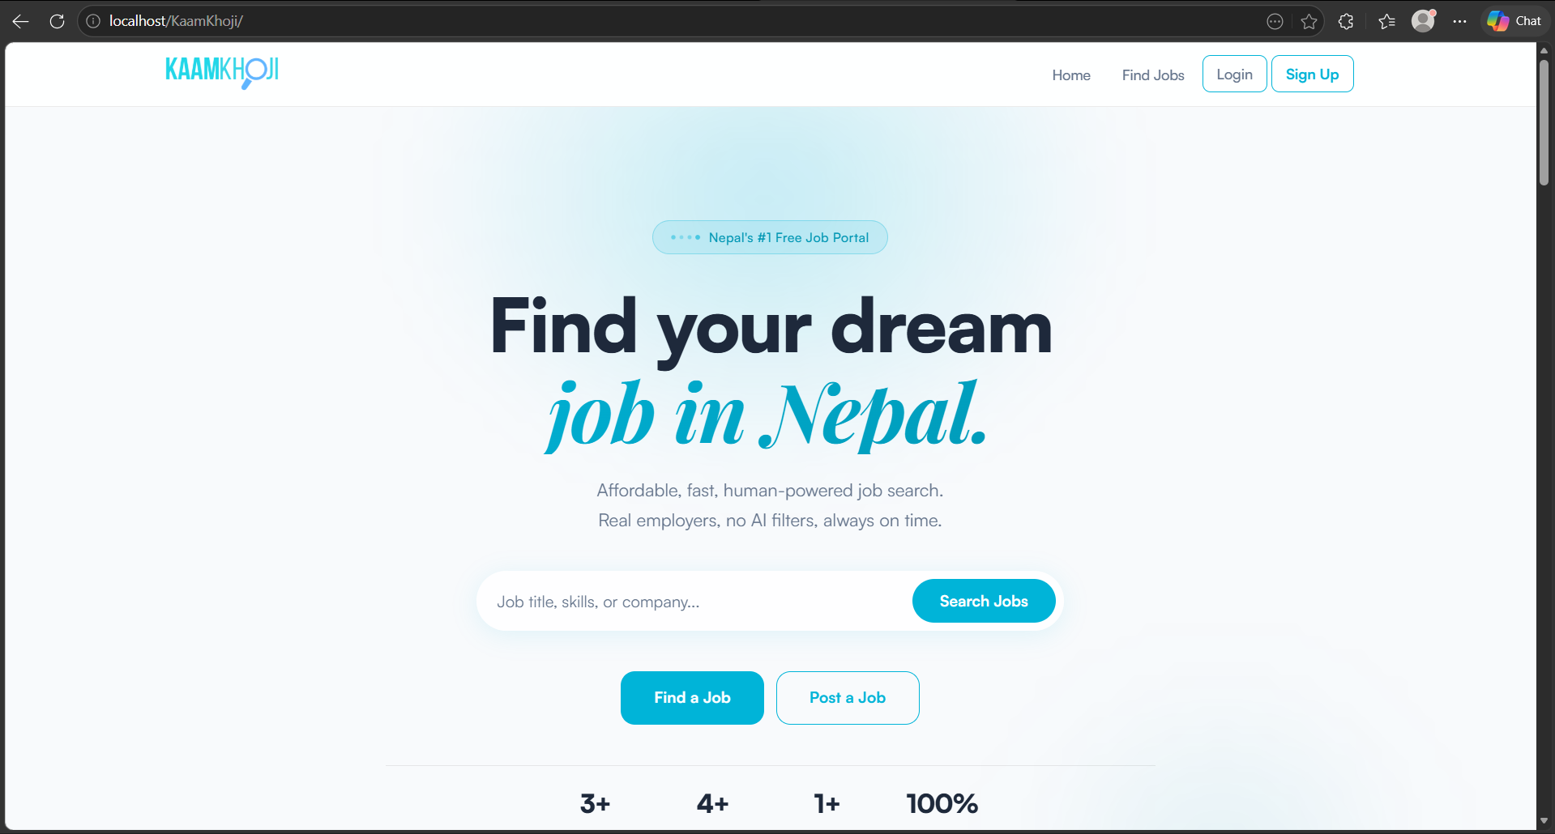
Fig :- KaamKhoji Landing Page
- Backend logic implementation: PHP scripts were written to handle form submissions, process user inputs, and interact with the MySQL database. Basic authentication logic was implemented for user login and registration.
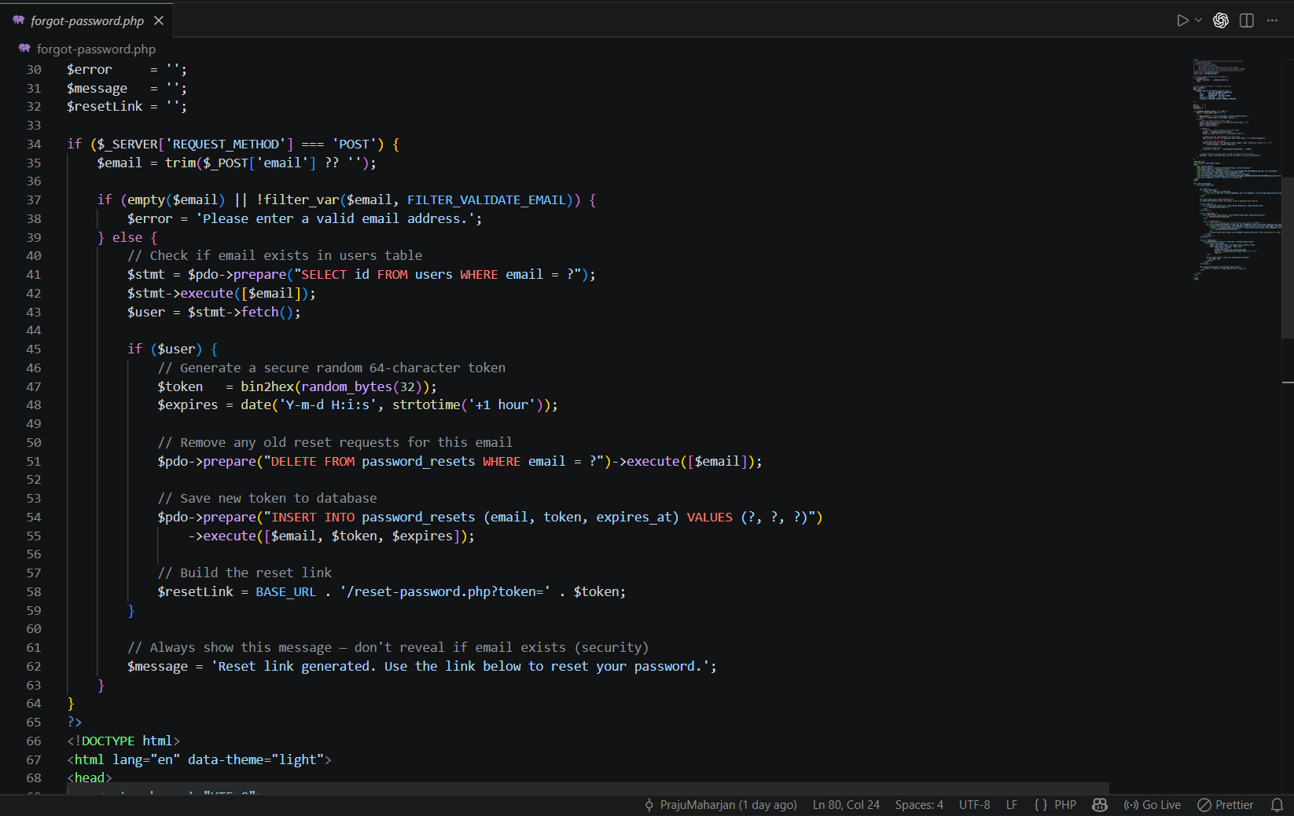
Fig :- Backend Feature-Forgot Password
- Frontend-backend integration: Initial integration between the frontend forms and backend PHP scripts was established, enabling data to flow between the user interface and the database.

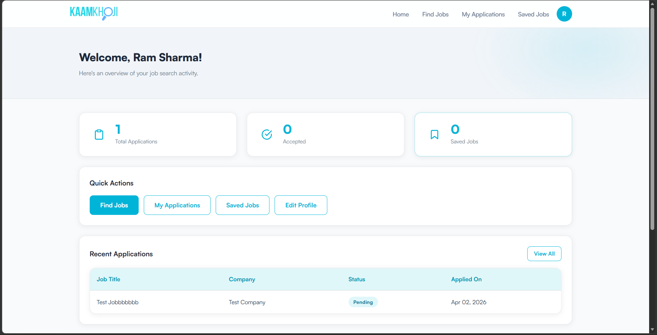
Fig :-2 Job Seeker DashBoard

- Testing and debugging: Basic functional testing was carried out to verify that the application behaved as expected. Issues identified during testing were documented and resolved within the sprint.

1.3. Appendix C (Use of Version Control)

GitHub was used as the version control system from the start of the sprint. A main repository was created, and all team members were given access to it. Different branches were used so that team members could work on separate features without affecting the main project. Once the work was completed, it was reviewed and then merged into the main branch using pull requests. Commits were made regularly to keep track of changes. Each commit included a message explaining what was done, which made it easier to understand the progress of the project. Most commits were followed up with an informal message on WhatsApp. GitHub also acted as a backup for the project, so no work would be lost if something happened to a developer’s local machine.

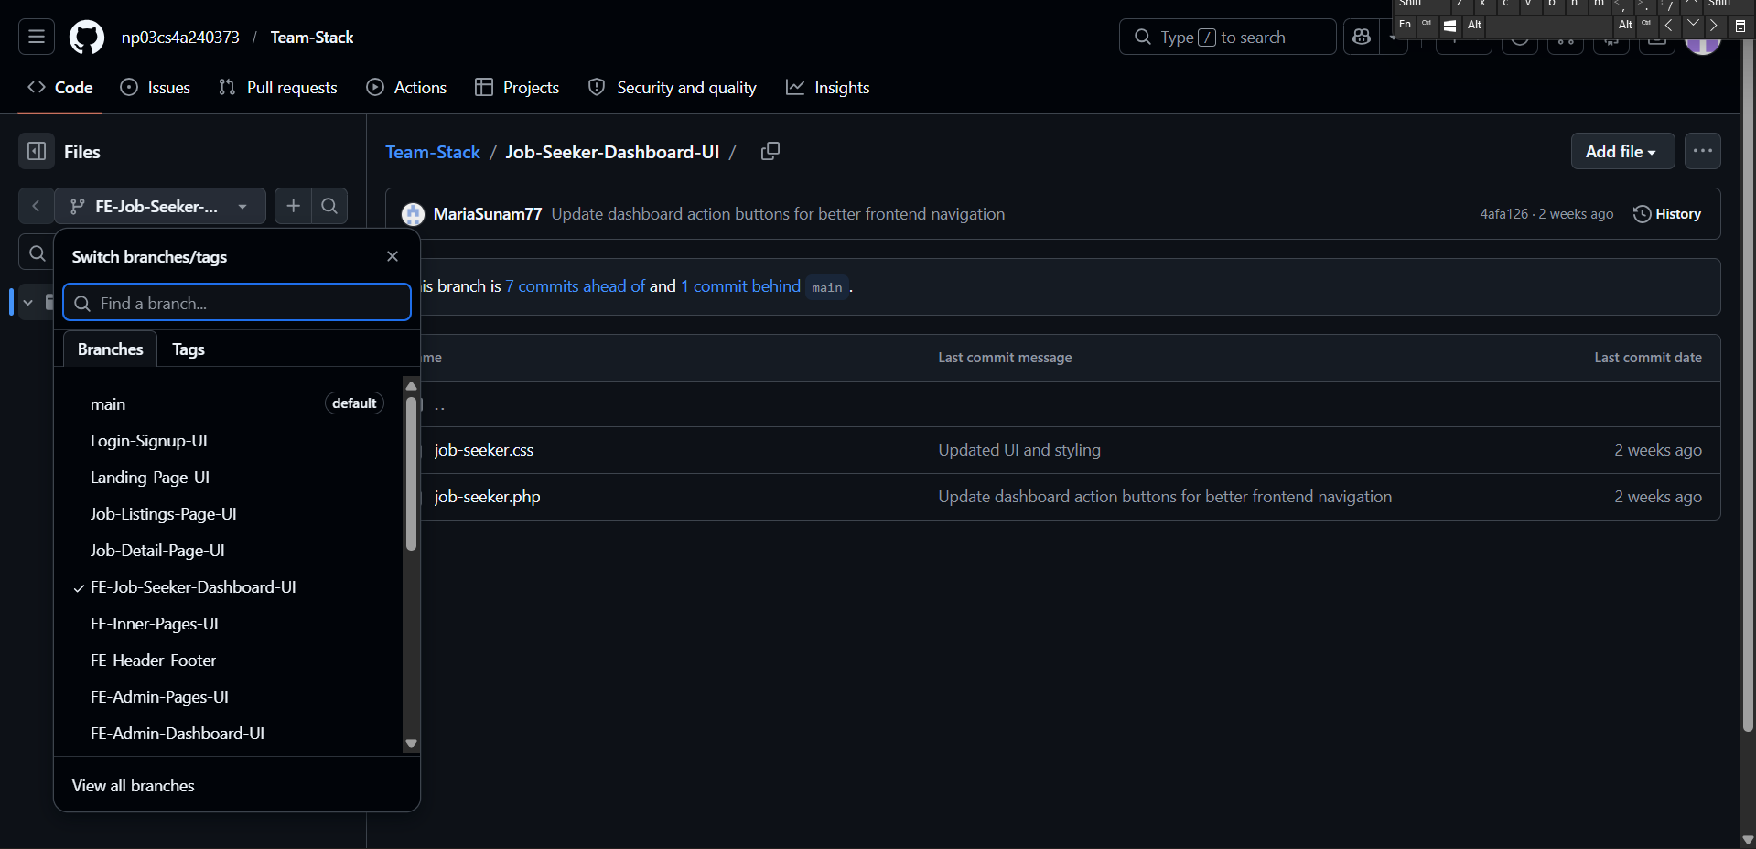
Fig :- Team repository with branches for each feature

1.4. Appendix D (Team Collaboration and Communication)

Throughout the sprint, effective communication was maintained by using different platforms depending on the type of task and its urgency. For quick updates and time-sensitive communication, the team used WhatsApp. This allowed members to stay connected, share information instantly, and coordinate daily activities efficiently.
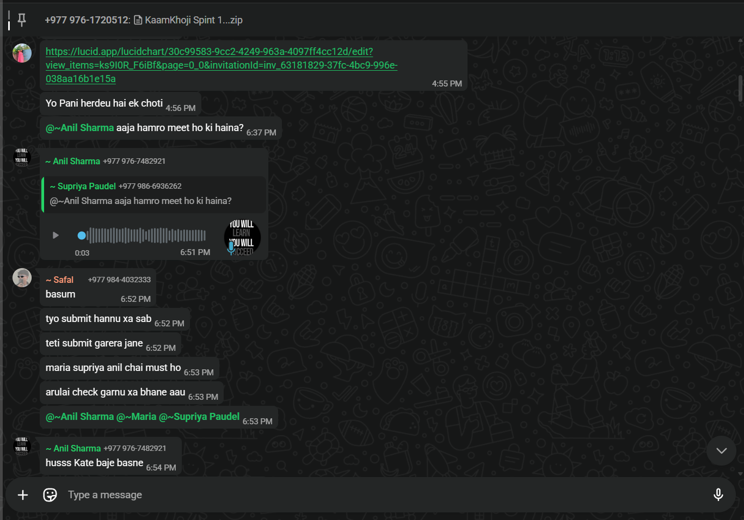
Fig :- WhatsApp Chat
For more detailed discussions, meetings and collaborative work, the social platform Discord was used. It provided a suitable platform for online meetings where team members could discuss complex tasks, resolve issues, and make decisions together.
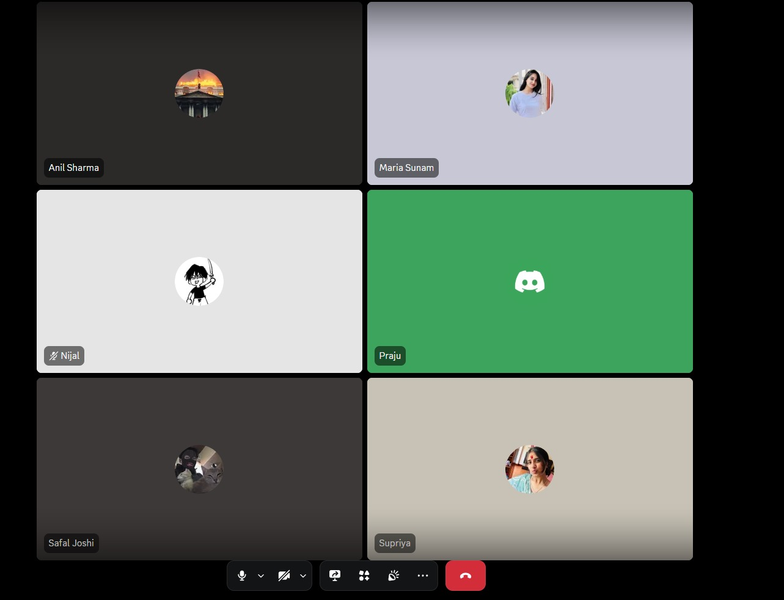
Fig :- Discord Meeting
Email was used in a more limited and formal way, mainly being sent by the project manager to inform team members about scheduled meetings and important announcements.
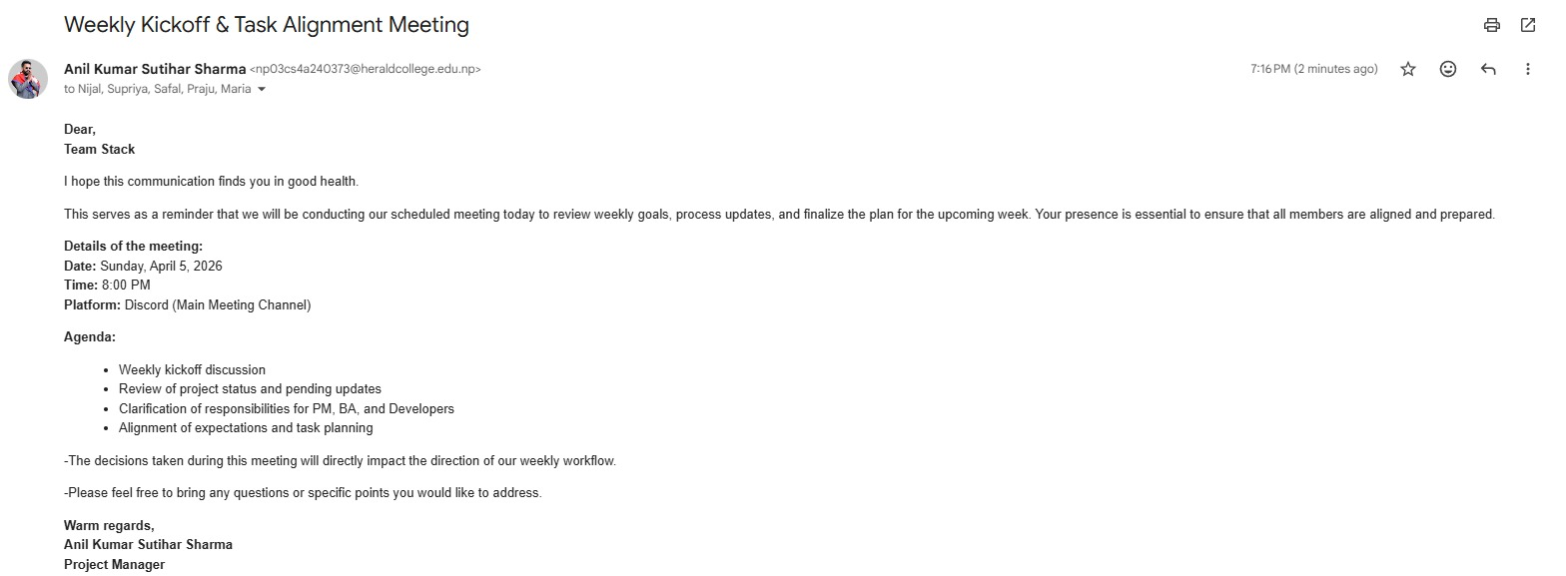
Fig :- Email for Scheduled Meeting
In addition to online communication, the team also held in-person meetings twice a week. These meetings were useful for sprint planning and issue tracking.
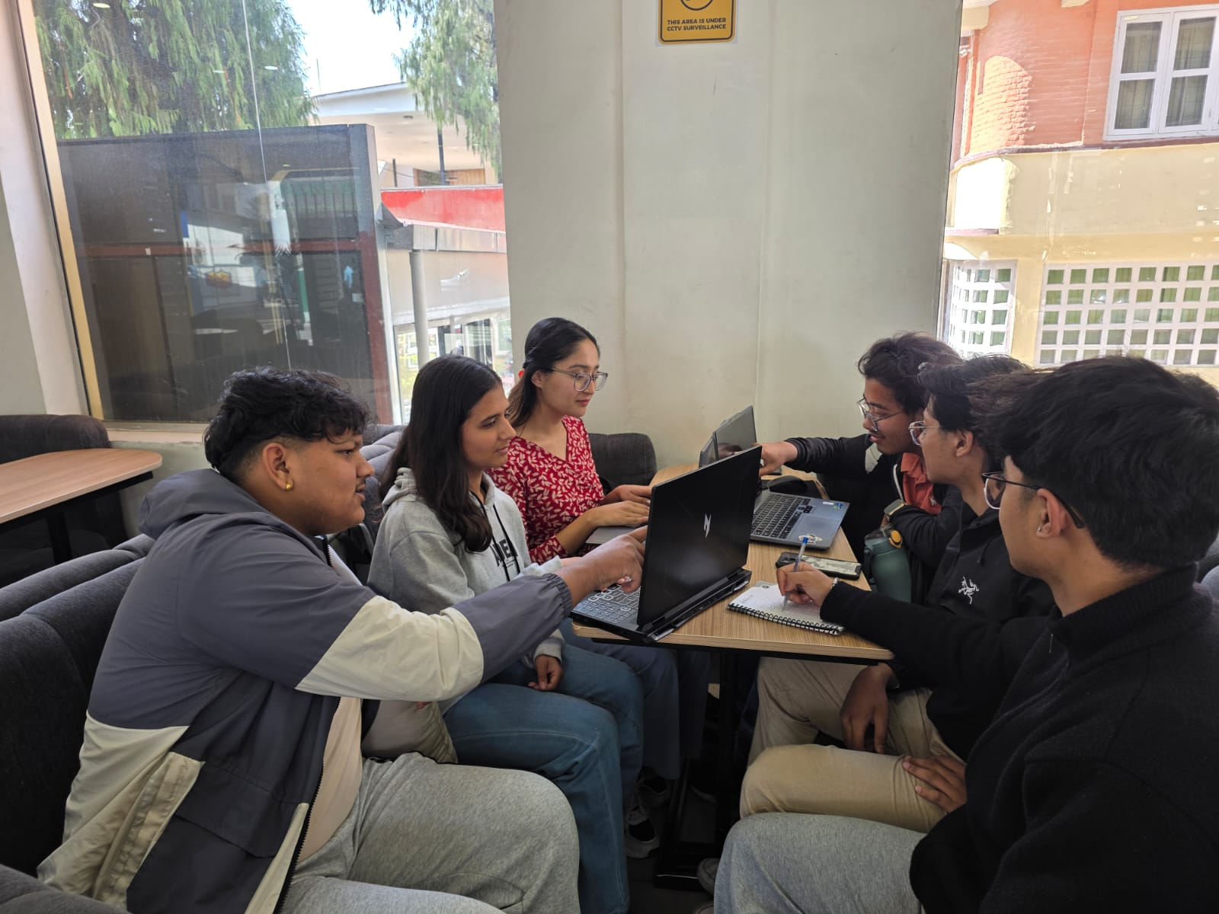
Fig :- In person Meeting
1.5. Appendix E (Sprint Review)
In Sprint 1, the team focused on planning and building the basic CRUD features of the Smart Job Portal System. The first goal was to complete the important parts of the system so that more advanced features could be done without worry.The team mainly worked on necessary features like user registration, login system, and separate dashboards for employers, job seekers and system admin. Other important features such as posting jobs, managing jobs, and tracking applications were also developed. These features served as the core functions of the job portal.
At the beginning, the team also thought about adding extra features such as a notification system. However, later it was decided to remove this idea because it would increase the workload and make the project harder to manage. By dropping unnecessary features, the team was able to focus more on completing the important ones properly.
Some features like chatting were not completely removed but moved to Sprint 2. This was done so that Sprint 1 could stay simple and focused. Sprint 2 will mainly focus on adding more advanced features, especially AI integration, along with completing features like chatting.
The main aim of the project was to create a system that works correctly and is secure. So, the team made sure that login and password handling were done properly and that job posting and application tracking worked as expected.
Overall, the team was able to complete the necessary features while avoiding extra headaches. By focusing on important tasks and delaying less important ones, the sprint was completed successfully.
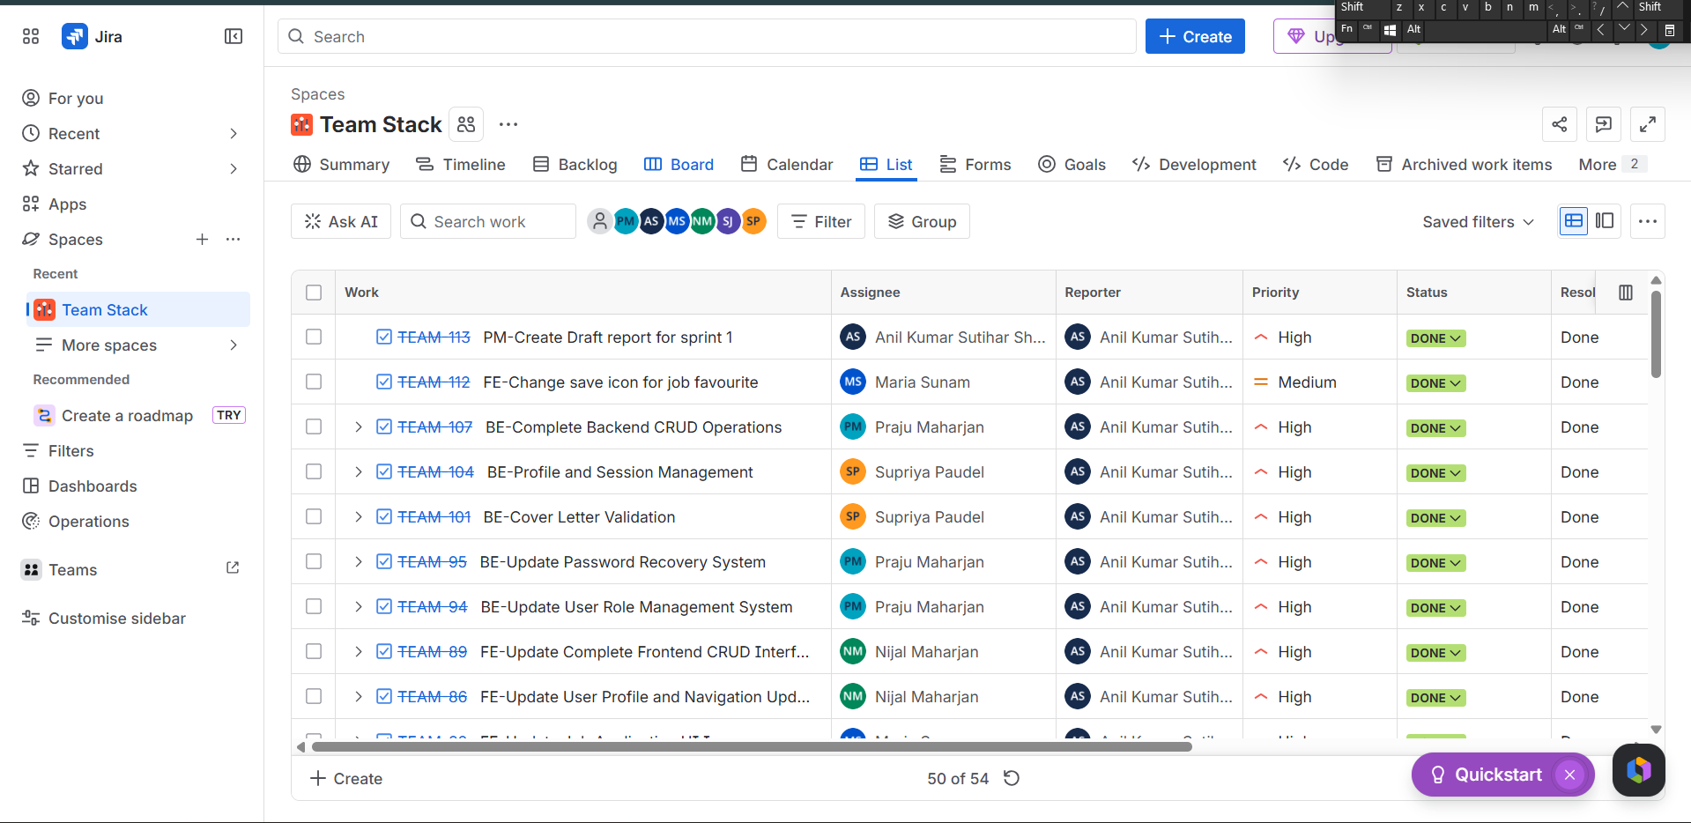
Fig :- Sprint Board(Jira) with completed tasks
2. Issue Tracking

Issues faced during development were mainly identified during testing and regular development work. When a bug or unexpected behaviour was found, it was noted with a clear description, including what the problem was and what was expected instead. In some cases, screenshots or code snippets were also used to make the issue easier to understand. Jira was mainly used to assign these issues to specific team members. Each issue was given to a member responsible for solving it, which helped ensure that tasks were clearly distributed within the team. Most of the problem-solving was done during online meetings, such as Discord sessions, as well as occasional in-person meetings. These discussions helped the team understand the issues better and find solutions more quickly.
By the end of Sprint 1, most of the issues have been resolved.

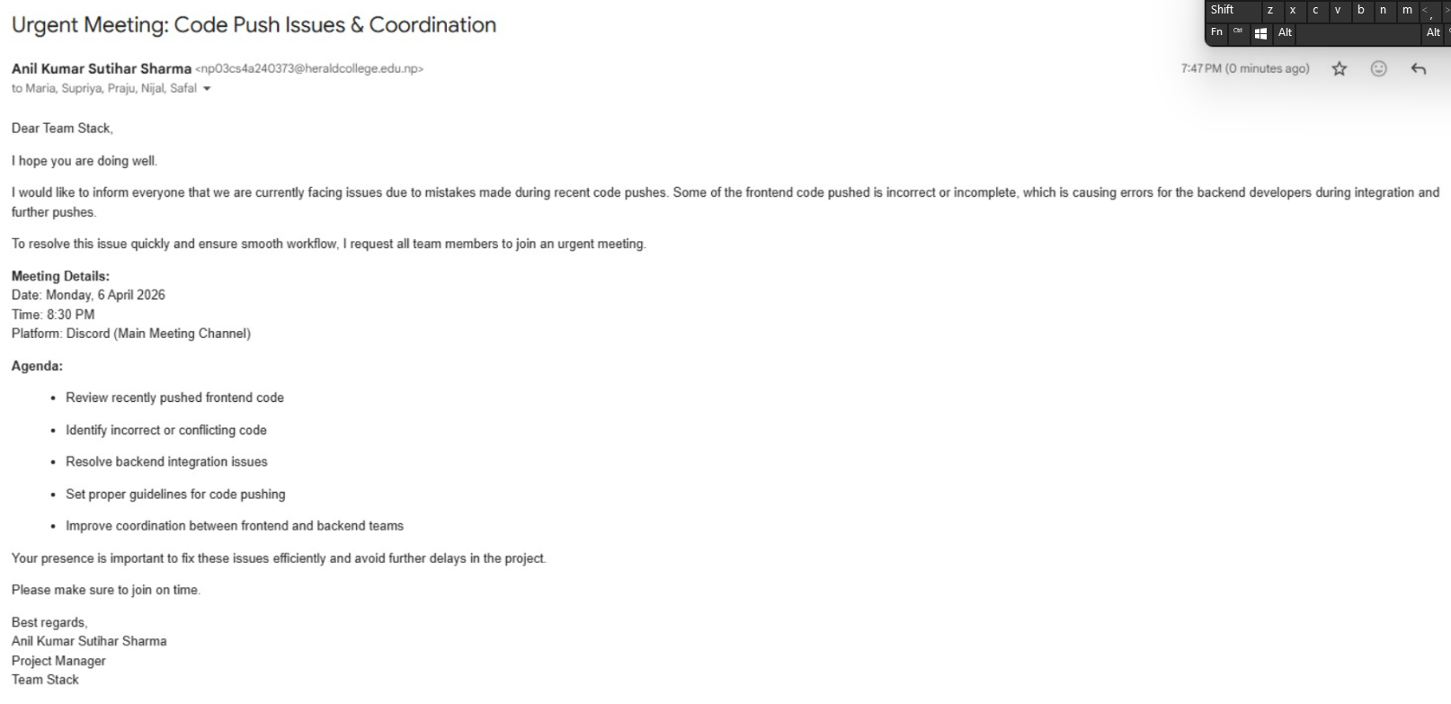

Fig :- Email sent for Issue Handling

3. Work to Deadline

Almost all the tasks planned for Sprint 1 were completed within the given deadline. This was possible because the entire team managed time properly and focused on completing the most important tasks first. At the start of the sprint, the workload was planned based on what the team could realistically handle, and some extra time was kept in case any unexpected problems came up. Instead of formal daily stand-up meetings, the team regularly checked progress through online discussions and occasional in-person meetings. This helped everyone stay updated on what others were doing and made it easier to identify any problems early. If any task took more time than expected, the team discussed it together and made small adjustments so that it could still be completed within the deadline. If completing the task within the deadline was impossible, the deadline was adjusted. Overall, good coordination and regular communication helped the team complete the sprint on time without affecting significantly the quality of the work.

4. Sprint Retrospective

4.1. What Went Well

- Version control was used regularly throughout the sprint. Team members made commits with clear messages, which made it easier to keep track of changes and understand the progress of the project.
- The main functional requirements were successfully completed within the sprint deadline. Important parts such as database setup, frontend pages, backend logic, and the connection between frontend and backend were all implemented properly.
- Jira was used to assign tasks to each team member, which helped in clearly dividing the work and making sure everyone knew their responsibilities.
- Communication within the team was good. Regular discussions through online platforms and occasional in-person meetings helped in identifying and solving problems quickly.
- The team stayed focused on the important features and avoided adding unnecessarily complex features, which helped in completing the sprint on time.

  - What Could Be Improved

- One of the main challenges during the sprint was schedule conflicts between team members. Since everyone had different availability, it was sometimes difficult to find a suitable time for meetings, which slowed down discussions and decision-making.
- Meeting notifications were sometimes sent too late. This made it difficult for some members to join on time or prepare in advance. Sending earlier notifications could help improve attendance and readiness.
- Task estimation could be improved. Some tasks took longer than expected, which required adjustments and affected the overall flow of work.
- Communication could be made more consistent. At times, updates were delayed, which caused minor confusion within the team.
- Having more structured planning and fixed meeting times could help improve coordination and reduce delays caused by scheduling issues.

- Conclusion

Sprint 1 came to an end successfully with all the core features being completed. Key features of the system included user registration and login, separate dashboards for employers, job seekers, and admins, job posting and application tracking, and a forgot password functionality. HTML, CSS, JavaScript, PHP, and MySQL were used to develop the project due to their ease of use and intercompatibility. Version control was achieved through Git and GitHub, in which branches based on new features helped in preventing system failure. Discord, WhatsApp, Gmail as well as in-person meetings kept us updated and on the same page about our development processes. Jira was used for task distribution among the team members.

While the sprint was mostly successful, few areas for improvement were identified including consistent communication and more structured meeting scheduling. All these issues will be covered in Sprint 2 of the project which includes AI integration and the postponed chat feature.

References
Atlassian (2024) ‘What is Jira? A guide to the project management tool’. Available at: https://www.atlassian.com/software/jira (Accessed: 18 March 2026).
Chacon, S. and Straub, B. (2014) ‘Pro Git’, 2nd edn. Apress. Available at: https://git-scm.com/book/en/v2 (Accessed: 18 March 2026).
GitHub (2024) ‘GitHub Docs: Getting started with GitHub’. Available at: https://docs.github.com/en/get-started (Accessed: 18 March 2026).
Mozilla Developer Network (2024) ‘HTML: HyperText Markup Language’. Available at: https://developer.mozilla.org/en-US/docs/Web/HTML (Accessed: 18 March 2026).
Mozilla Developer Network (2024) ‘JavaScript Guide’. Available at: https://developer.mozilla.org/en-US/docs/Web/JavaScript/Guide (Accessed: 18 March 2026).
Oracle (2024) ‘MySQL 8.0 Reference Manual’. Available at: https://dev.mysql.com/doc/refman/8.0/en/ (Accessed: 18 March 2026).
PHP Group (2024) ‘PHP: Hypertext Preprocessor Documentation’. Available at: https://www.php.net/docs.php (Accessed: 28 March 2026).

